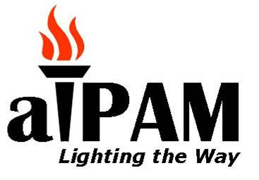 | Association of Illinois Patient Access Management  Vendor Conference Sign Up Sheet
This Sign Up Sheet is for the below indicated Annual aIPAM Vendor Event.
Semi Annual Event:  Fall Conference: X  Spring Conference: | Participating Organization Information:  Primary Contact:  Company:  Address:  Phone: Fax:  Email:  Website:
Please contact Amanda Hayes, Amanda.hayes@presencehealth.com to confirm there is still space available.
Details:
Date | September 28th, 2017
Time | 7:30a.m.-5:00p.m.
Location | Belvedere Events and Banquets.1170 West Devon Elk Grove Village, IL

As a celebration of our 25th event we are offering some additional options to get our sponsors more exposure:
Description | Cost | # | Total
Platinum: Logo and link at the top of all emails/website, 10 minute presentation & QA, 3 attendees, brochure and event recognition. Max 1 | 1,750.00
Gold: Logo and link middle of all emails/website, 5 minute presentation & QA, 2 attendees, brochure and event recognition. Max 2 | $1500.00
Silver: Logo and link end of all emails/website, 2.5 minute presentation QA, 2 attendees, brochure and event recognition. Max 3 | $1,250.00
Bronze: Logo and link on /website, 1 minute presentation QA, 1 attendee, brochure and event recognition. Max 4 | $1,000.00
Booth Only 1 attendee, brochure and event recognition. | $500.00
Breakfast Sponsor (multiple). Does not include Attendee registration | 250.00
Lunch Sponsor (multiple). Does not include Attendee registration | 500.00
Cocktail Sponsor (multiple). Does not include Attendee registration | 700.00
Additional Attendees | $125.00
We will provide a raffle prize please contact:  Name: Email: Phone:  Item to raffle: | Please Circle Either  Yes / No
*note which packages require separate additional attendee registration and payment. | Total
Payment must be received by September 15th to confirm your spot. Register early to be included in all event marketing. Alternately, we can send you a paypal invoice to let you pay online. Contact Lee Remen at lremen@aipam.net for more info

Checks should made payable to “AIPAM” and sent with this form to:
aIPAM, PO BOX 847, Cary IL 60013

Questions, contact: Amanda Hayes amanda.hayes@presencehealth.org Office: 630.914.2129
Mobile: 815.666.8255

